Early Middle Ages

- Who had the most power in Middle Ages? Why? (list ALL the reasons)

The Church was the most powerful institution in the Middle Ages. Christianity was the one thing that unified Western Europe after the fall of the Western Roman Empire. The clergy were the only ones who learned to read and write, in order that they might preserve and copy biblical texts.
Over time people relied on them to keep records of secular events and matters, as well.

During the Middle Ages, the Pope anointed the Emperors, missionaries carried Christianity to the Germanic tribes, and the Church served the social, political, and religious needs of the people.

- What 3 elements made the foundation for early medieval society?
  - Classical heritage of Rome
  - Christian beliefs
  - Customs of Germanic tribes

- Give examples of how the Catholic Church influenced medieval society?

Influence of the Roman Catholic Church
- Secular authority declined, while Church authority grew.
- Monasteries preserved Greco-Roman cultural achievements.
- Missionaries carried Christianity and Latin alphabet to Germanic tribes.
- The Pope anointed Charlemagne Emperor in 800 A.D. (C.E.)
- Parish priests served religious and social needs of the people.

- In the space below, draw a chart that explains the Medieval Feudal System:
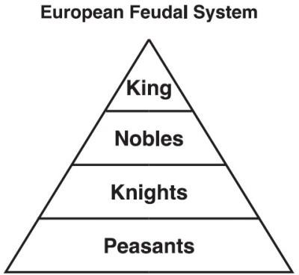
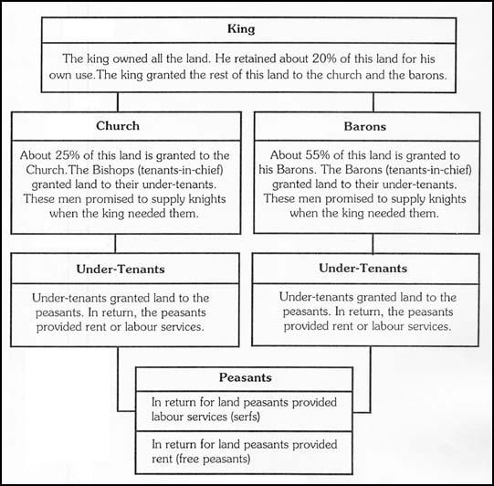
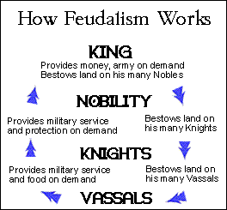

- Why did Western Europe develop the feudal system?

Feudalism developed in Europe in response to the breakdown in central authority in the Frankish
empire following Charlemagne’s death and also because of the instability and chaos caused by the numerous invasions in the 9th and 10th centuries, esp. by the Vikings from Scandinavia. It was a way of life that involved agreements, promises, and exchanges between different groups of people to help them live together. It involved social, economic and political relationships.

Feudal society during the Middle Ages
- Fiefs—land grants given in exchange for service
- Vassals—nobles who served as leaders of armies and certain sections of a king or lord’s land
- Serfs—individuals (peasants) bound to land they were born—not allowed to leave
- Feudal obligations—services owed in exchange for land or the right to use the land (ex. Peasants owed labor in exchange for being allowed to live and eat off the land)
- What was the manorial system?
An economic and social system based on the ownership and distribution of land in exchange for services. (see the Medieval Life image in #99).

The manor system was self-sufficient (provided everything basic that was needed; only needed to import salt and iron; few luxury goods were available). It was a system that included a very rigid social structure (everyone belonged to a certain class and was not allowed to become part of a different class).

- Who was Charlemagne and why was he significant in the Middle Ages?

Charlemagne was the son of Pepin the Short (son of Charles “the Hammer” Martel). Charlemagne inherited a position of king of the Franks. He was the only leader successful at uniting the Western European region during the Middle Ages. He united the Frankish lands into one empire, under himself as the king. He was crowned Holy Roman Emperor by the Pope himself. Thus, he used Christianity to unite the Franks as well.

Age of Charlemagne
- Franks emerged as a force in Western Europe.
- The Pope crowned the Emperor.
- Power of the Church was established in political life.
- Roman culture was reinterpreted.
- Most of Western Europe was included in the new empire.
- Churches, roads, and schools were built to unite the empire.

- On the map below, outline Charlemagne’s Empire:
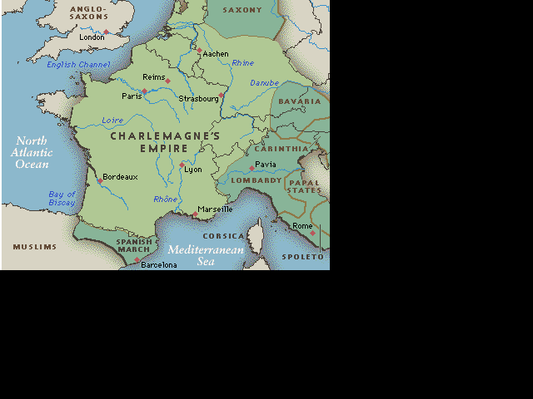
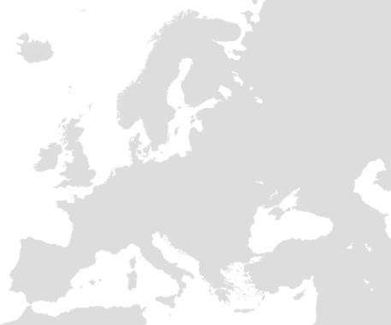
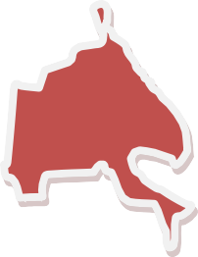
Charlemagne’s
Empire

- Who were the Vikings and how did they influence the development of Europe during the Middle Ages?

Influence of the Angles, Saxons, Magyars, and Vikings
- Manors with castles provided protection from invaders, reinforcing the feudal system.
- Invasions disrupted trade, towns declined, and the feudal system was strengthened.

- Using the map below, label the following:

Migration of Angles and Saxons Migration of Magyars Migration of Vikings

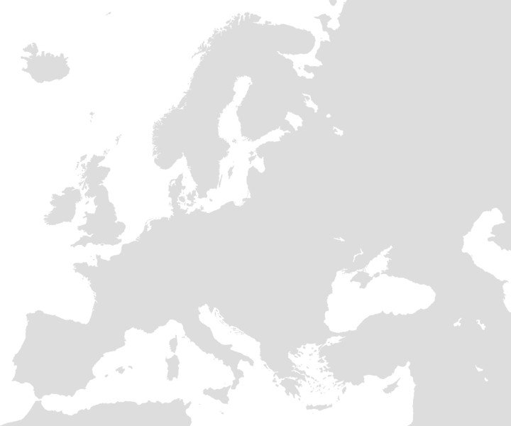
Scandinavia

↙Vikings Vikings Vikings →→→→→→
↓

← Angles & Saxons

Continental Europe

← Magyars Magyars Magyars

Central Asia

Areas of settlement
- Angles and Saxons migrated from continental Europe to England.
- Magyars migrated from Central Asia to Hungary.
- Vikings migrated from Scandinavia to Russia.

Eastern Hemisphere

- Label the following trade routes on the map below. Use a different color for each trade route and create a key:

Silk Road
- Maritime Routes

Trans-Saharan Routes
- Northern European Routes

Western European Routes
- South China Sea Route

Major trade patterns of the Eastern Hemisphere from 1000 to 1500 A.D. (C.E.)
- Silk Routes across Asia to the Mediterranean basin
- Maritime routes across the Indian Ocean
- Trans-Saharan routes across North Africa
- Northern European links with the Black Sea
- Western European sea and river trade
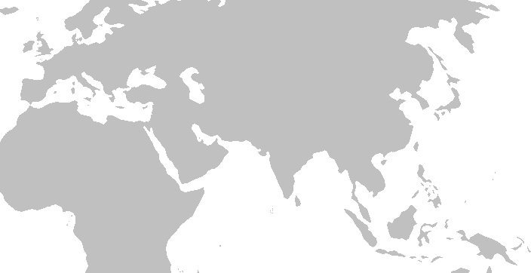
- South China Sea and lands of Southeast Asia
North
Europe
o
Black Sea

Silk Roads Silk Roads Silk Roads Silk Roads
Trans-Saharan routes
SE
Asia
Maritime routes Maritime routes
South China
Sea

- What is cultural diffusion? Give an example.

Spread of an idea from one group of people to another
Example: dome—Romans originally adopted from the Etruscans; the dome was later used in the Byzantine Empire, the Muslim empire, and post-Mongol Russia (Ivan the Great’s time)

- How did trade facilitate the diffusion of goods and ideas among different culture?

Trade caused peoples from one region to come into contact with peoples from other regions. The following are some ways that ideas were spread from one culture to another:

Technology
- Paper from China through the Muslim world to Byzantium and Western Europe
- New crops from India (e.g., for making sugar)
- Waterwheels and windmills from the

Middle East
- Navigation: Compass from China, lateen sail from Indian Ocean region

Ideas
- Spread of religions across the hemisphere
- Buddhism from China to Korea and Japan
- Hinduism and Buddhism from India to Southeast Asia
- Islam into West Africa, Central and Southeast Asia
- Printing and paper money from China

- Using the map below, locate and label where the following goods and technology came from. Gold, Spices, Textiles, Porcelain, Amber, Paper, Making Sugar, Waterwheels, Windmills, Compass, and Lateen Sail.
Amber
Textiles
(later)
Porcelain
Textiles (Persia)
Porcelain
Textiles
Textiles
Spices
Gold
Gold
Spices

Goods
- Gold from West Africa
- Spices from lands around the Indian Ocean
- Textiles from India, China, the Middle East, and later Europe
- Porcelain from China and Persia
- Amber from the Baltic region

- How did Japan’s geography influence its development?

- Mountainous Japanese archipelago (four main islands)
- Sea of Japan or East Sea between Japan and Asian mainland
- Proximity to China and Korea

- Give 3 specific examples of how Chinese culture influenced Japan.

- Writing
- Architecture
- Buddhism

- Give a title to the chart below:

Shintoism
- Ethnic religion unique to Japan
- Importance of natural features, forces of nature, and ancestors
- State religion, worship of the emperor
- Coexistence with Buddhism

- Using the map below, label the following African Civilizations: Axum, Zimbabwe, Ghana, Mali, Songhai, and City of Timbuktu
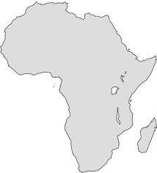
Ghana, Mali, Songhai
Timbuktu
Axum
Zimbabwe

- What were the characteristics of the civilizations mentioned in question 113?

Axum
- Location relative to the Ethiopian Highlands and the Nile River
- Christian kingdom

Zimbabwe
- Location relative to the Zambezi and Limpopo rivers and the Indian Ocean coast
- City of “Great Zimbabwe” as capital of a prosperous empire

West African kingdoms—Ghana, Mali, (Songhai)
- Location of Ghana, Mali, and Songhai empires relative to Niger River and the Sahara
- Importance of gold and salt to trans- Saharan trade
- City of Timbuktu as center of trade and learning
- Roles of animism and Islam

- Complete the following chart:
 | Mayan | Aztec | Incan
Location
Famous City
Government
Economy
Religion
Achievements

Mayan civilization
- Located in the Mexican and Central American rain forests
- Represented by Chichén Itzá
- Groups of city-states ruled by kings
- Economy based on agriculture and trade
- Polytheistic religion: Pyramids

Aztec civilization
- Located in arid valley in central Mexico
- Represented by Tenochtitlan
- Ruled by an emperor
- Economy based on agriculture and tribute from conquered peoples
- Polytheistic religion: Pyramids, rituals

Incan civilization
- Located in the Andes Mountains of South America
- Represented by Machu Picchu
- Ruled by an emperor
- Economy based on high-altitude agriculture
- Polytheistic religion
- Road system

Achievements of Mayan, Aztec, and Incan civilizations
- Calendars
- Mathematics
- Writing and other record-keeping systems

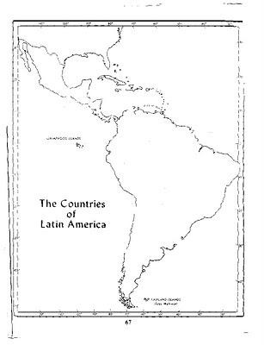
- Label the civilizations in questions 115 on the map below:
Aztecs
Mayan
Incan
Incan
Incan Incan

